1. **My profile:**

* **Name:** Nguyen Huu Gia Thanh
* **DOB**: 01/11/2002
* **Student number**: s3932584
* **Email address**: [s3932584@rmit.edu.vn](mailto:s3932584@rmit.edu.vn)
* **Nationality**: Vietnamese
* **Background**: I was born in Ho Chi Minh city. Since I was in third grade, my family has moved to Hanoi, the capital of Vietnam because it is where my father’s extended family live and work. I have graduated from Chu Van A high school, one of the most popular and prestigious high school in Vietnam, especially in Hanoi. After that, I passed the national exam with 27 points. I can speak two languages: Vietnamese which is my mother tongue and English. There are a lot of benefits when studying English that I can have more foreign friends by using it to communicate with them. Moreover, it helps me very much when I must do research due to a great deal of orthodox information are written in English.
* **Hobbies:** I really like playing basketball. When I was a child, my mother took me to the basketball court and I saw people had fun with each other through the they played, worked as a team, and somehow the passion with the orange ball came to my mind. I rarely do exercise at home, so after the school break, my bestie and I always go to the court near our homes to play basketball for relaxation. Besides, I am a huge fan of League of Legend, one of the most popular MOBA game in the world. I used to play it a lot with my secondary school friends but since I went to high school, I had to manage my time efficiently, therefore, I just play games once or twice a week since there are a lot of other things to deal with.
* **Facts of me:**

I was an extroverted person, however, after going through many hardships, I gradually become shy when facing others. My father has suffered from muscular disorder in his neck after taking me to school since I was at 10th grade. As a result, I felt very guilty whenever recalling that period since I thought that I was one of the factors contributing to his disease.

I chose to study Information Technology because I want to know more about cyberspace, how it works, and how to make it. Moreover, the secondary reason that I study IT (Information and Technology) (Information and Technology) is to make my parents and my sister proud of me.

1. **Interest in IT:**

**What is your interest in IT? When did your interest in IT start? Was there a particular event or person that sparked your interest? Outline your IT experience**

There are so many reasons why I choose to study information technology. First, it allows me to choose my career paths in a number of directions. To become a game developer, a cybersecurity professional, a web developer, and so on. Now, I want to be a cybersecurity professional, however, during the study progress I may be interested in other fields which are completely suitable for me. Secondly, according to the rise of the fourth industrial revolution, every innovative technology can be behind the times in the speed of light, and I enjoy when working in an environment that always encourages me to never stop learning. Finally, like everyone around world, I learn and work for my passion and making livelihood, and nothing is better than when doing something that you love and are willing to do to earn money.

Since I was in 7th grade, I curiously saw my cousins writing something on his computer. I wondered what language he was doing with, then he told me that he was coding a program for his assignment. He broadened my imagination by showing me some works of his. After that, he explained that all vivid pages and games are the logical combination of algorithms written by web and game developers. Moreover, I was surprised by the way he hacked the game by injecting some short code into the program and imagined one day I could do so. After that period, I gradually liked programming and searched for some simple programs that helped me very much in high school.

**Why did you choose to come to RMIT (Royal Melbourne Institute of Technology)?**

I chose to come to RMIT because it is where I can improve diverse aspects of my personality. First, RMIT has a wide variety of clubs in many fields, from sports to social activities, and so on. As a fan of basketball, I can take part in the RMIT Basketball Club, besides, I find it very great to be engaged in the RMIT Event Club (REC) where I can make a lot of friends and enhance my soft skills. Moreover, at RMIT, there are many facilities that can go with me in my study. Computer labs where I think I will be always absorbed in; it provides me a powerful gear with a CPU (Central Processing Unit) Intel Xeon chip, VGA Quadro 2200, that may seem to be superfluous for IT purposes but may adapt to my uses of rendering photos. Besides, one of the prerequisite factors that I chose to study here is the library. It has a diversity of authorized books, articles that I need for my study researches as many its counterparts do not have.

**What do you expect to learn during your studies?**

As being a student, I expect to learn something new and suitable for my future career. Besides learning some theoretical things included in the curriculum, I want to broaden my horizon by communicating with other people, then I can improve my soft skills that are needed when finding a job or working with strangers.

1. **Ideal job:**

Link: <https://itviec.com/it-jobs/data-engineer-up-to-2500-no-probation-fpt-software-4614?lab_feature=employer_job>

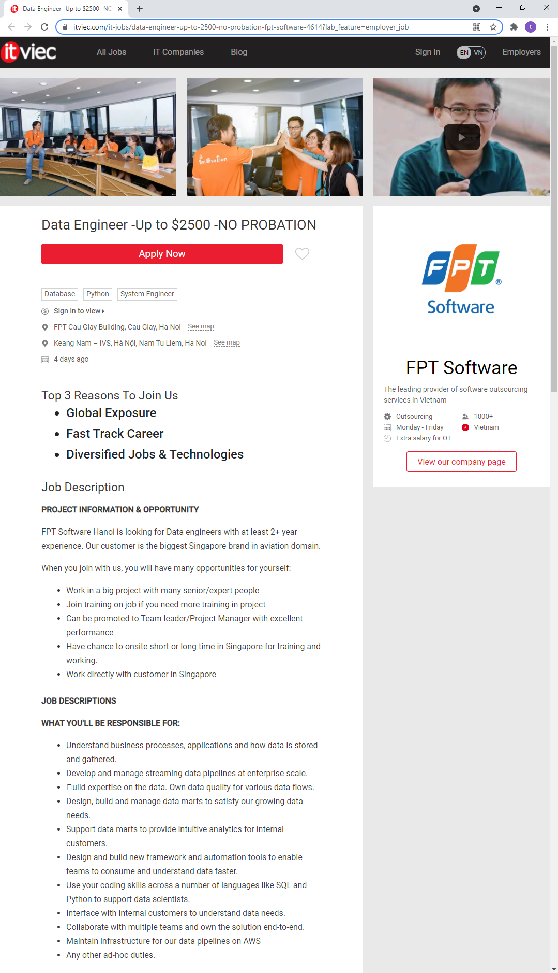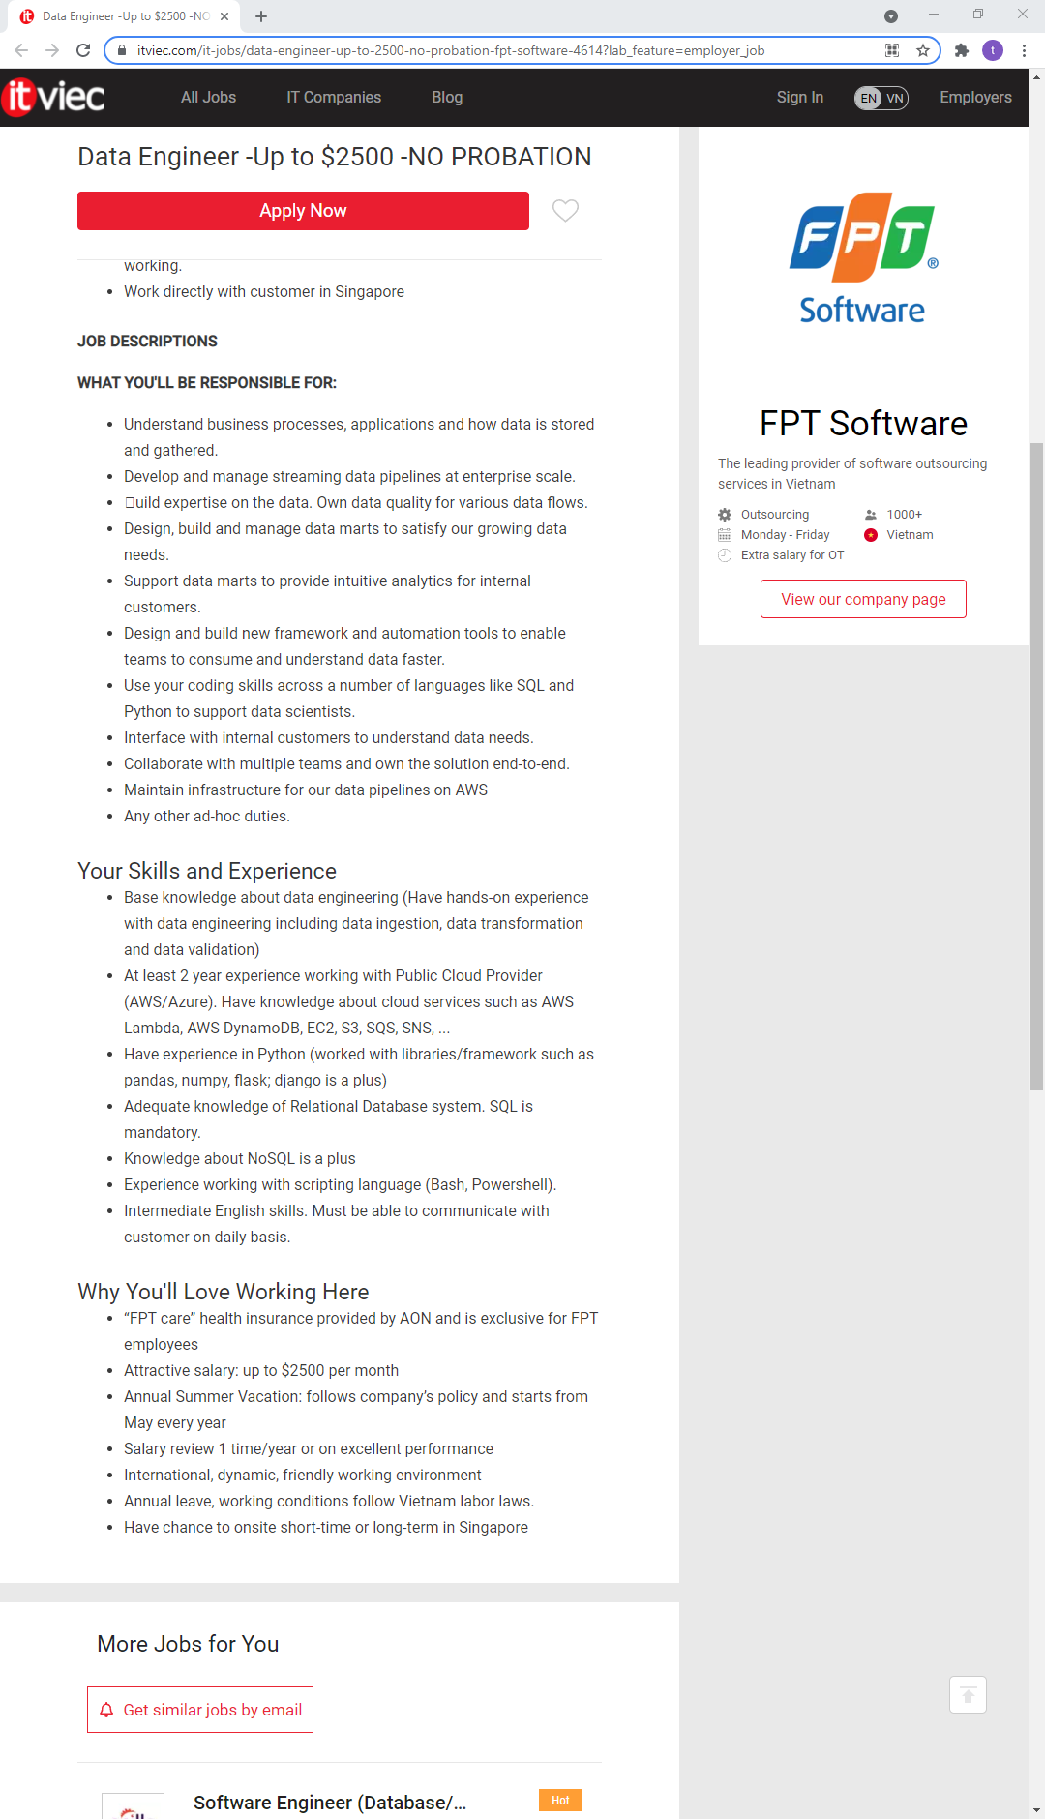

**A description (in your own words) of the position, and particularly what makes this position appeals to you.**

In this position, the staff must comprehensively understand the business’s properties such as: data, applications, and the like. After that, they must enhance and check the data pipelines at business scope. Besides, staff need to build and manage up-to-date systems to accommodate the growing data then supply the intuitive analytics for internal customers. Moreover, the staff must understand the habitual uses of other teams to perfect the framework and automation tools for faster information consuming and understanding. Moreover, coding skills are necessary to support the data scientists. Furthermore, the staff have opportunities to collaborate with multiple teams and bring out the solution for wide range of problems. As a data engineer, supporting infrastructure for the business data pipelines on Amazon Web Services (AWS) which supplies cloud platforms following the uses of individuals, companies, and so on. At a personal level, I find it remarkably interesting when dealing with problems related to Cloud, so the job would be suitable for me.

**A description (in your own words) of the skills, qualifications, and experience needed for the position.**

For applying to the job vacancy, you must have a fundamental knowledge of data engineering including data ingestion, data transformation and data validation. People should have 2 years' experience with Public Cloud Provider such as: AWS, SNS, and the like. Besides, the applicant’s knowledge of using Python along with its libraries, packages; you can take advantage over the others by understanding the application of Pandas, NumPy, flask, Django. Moreover, you must be knowledgeable about Relational Database system and SQL is indispensable. Together with these skills, you may also have experience using scripting languages like PowerShell, Bash. The job also requires you to have sufficient English to be able to communicate with the customers regularly

**A description (in your own words) of the skills, qualifications, and experience you currently have.**

As I am an administrator of my family’s company, I have ability to manage my own employees to make a good working environment. Moreover, now, I simultaneously study and work at my home, so I am able to perfect my daily routine efficiently. Besides, I am a good English user with about 6 years’ experience. Nevertheless, I get started with my IT studies, as a result, I do not have much experiences in this field. However, I always do self-study, so I can improve these skills as soon as possible.

**A plan describing how you will obtain the skills, qualifications, and experience needed for the position, building on those you have now. This need not be greatly detailed, (and will probably change significantly over time anyway), but try to be as specific as you can.**

As being an IT student, I constantly improve my programming skills and broaden my knowledge of information technology. Meanwhile, I can spend 2-3 hours a day to do some self-research about the Public Cloud Provider which is needed for the job. Besides, in other spare time, I will spend time to read books about Relational Database and the like. Finally, keep improving my English skills and learn one more foreign language, if I had to choose, I would prefer Chinese because China is a second largest nation that IT is developing dramatically, and it is where my grandfather was born.

**4.Personal Profile:**

**-The results of an online Myers-Briggs test:** <https://www.16personalities.com/entj-personality>

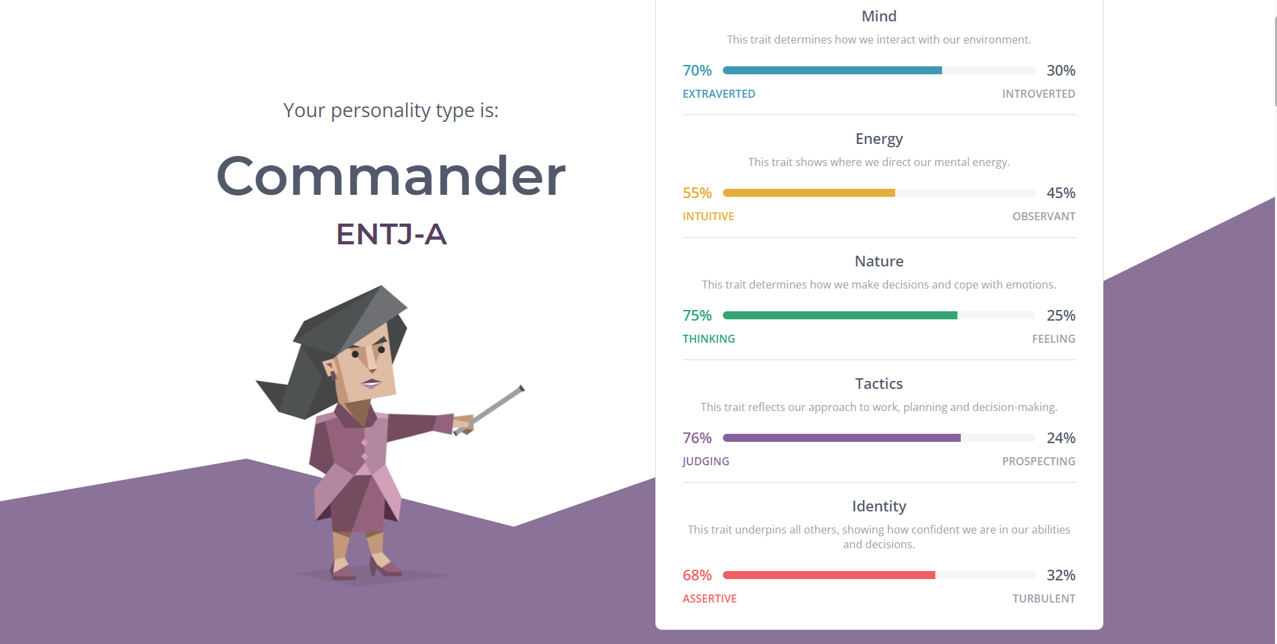

**- The results of an online learning style test:**

Link: http://www.educationplanner.org/students/self-assessments/learning-styles-quiz.shtml?event=results&A=7&V=6&T=7

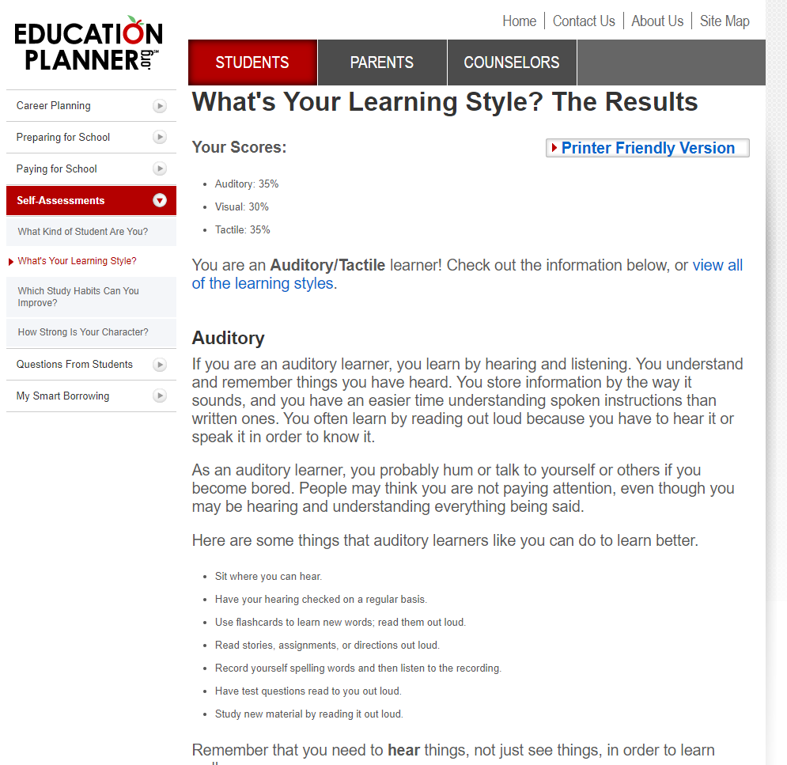

* **The results of Big Five Personality Test:**

Link: https://www.truity.com/test-results/bigfive/17315/23329842

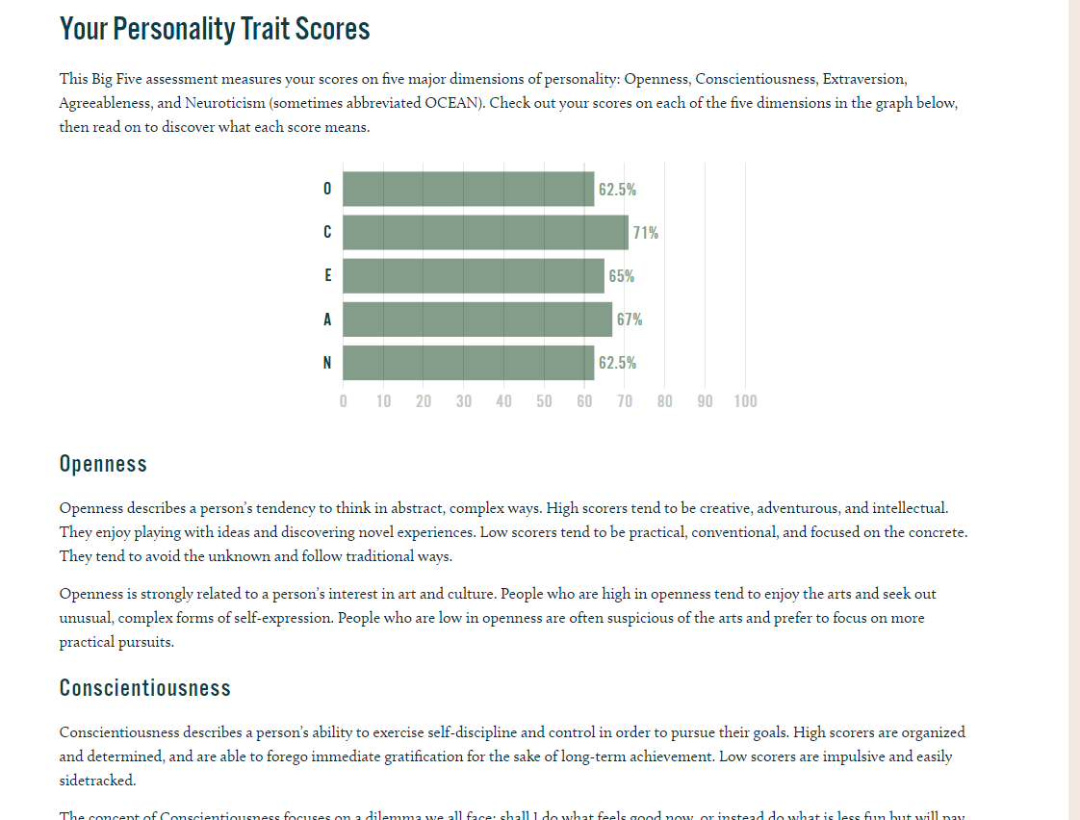

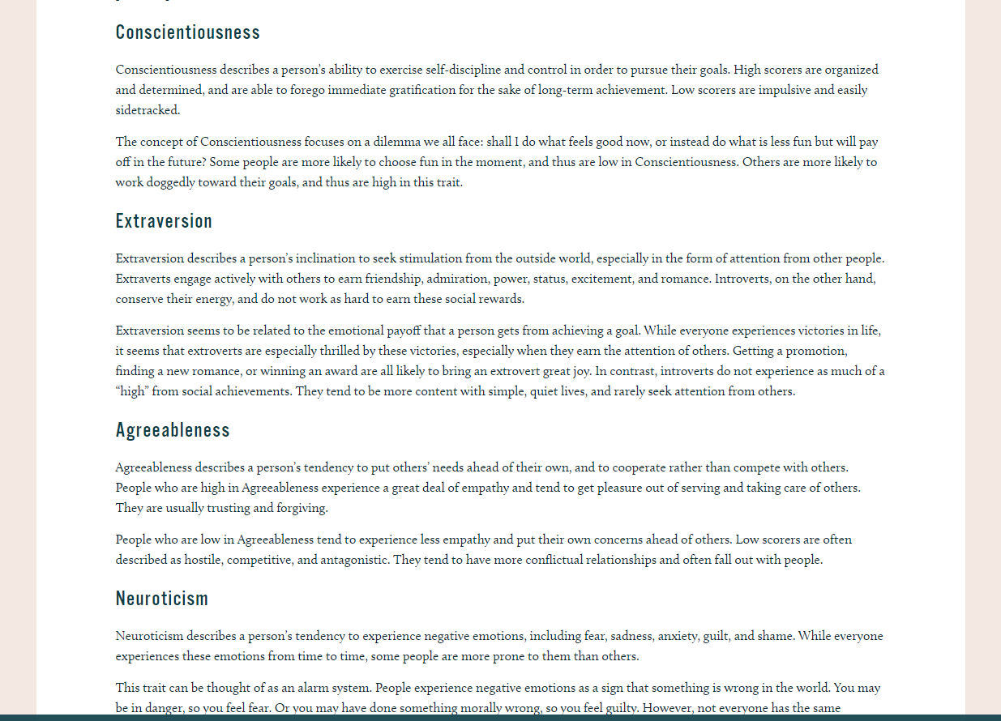

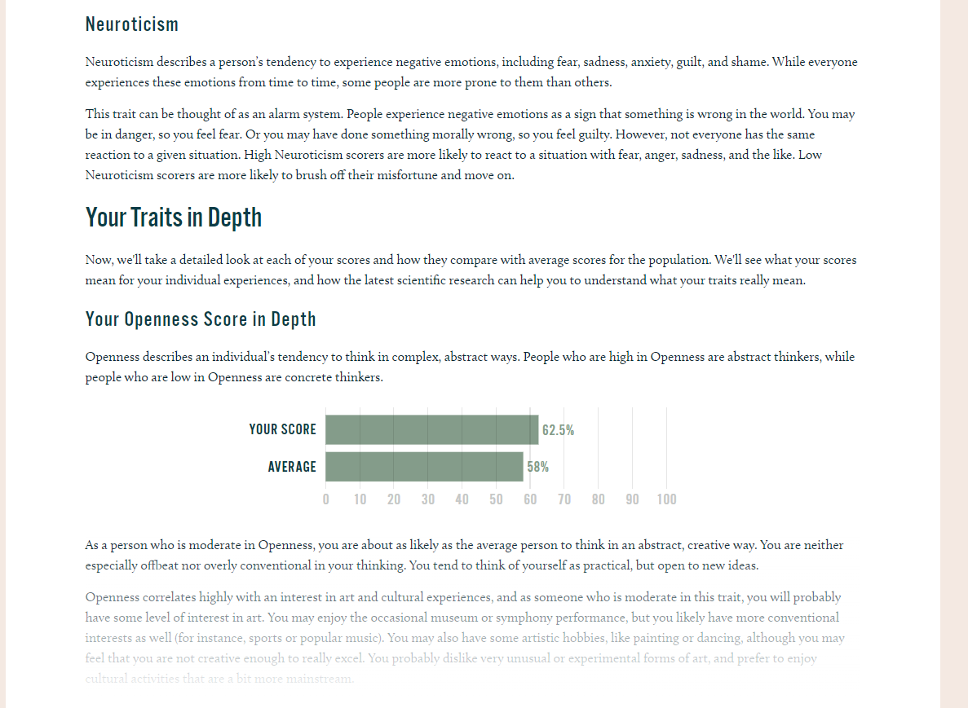

**What do the results of these tests mean for you?**

The results of these tests seem both right and wrong to me. It shows some of my drawbacks which I could hardly see by myself. Therefore, I have an opportunity to change my mind, improve to be a better version of myself. In many aspects of one’s life, we both must be hard-hearted and sensitive. After having done the test, I find it necessary to listen and lean a sympathy ear to others’ feelings. Moreover, besides telling me who I am, the learning style test provides me with a wide range of tailor-made methods that help me to learn better. On the other hand, the tests only illustrate parts of my personality, and hardly can define me accurately. Therefore, rather than believe in the strong points shown in these tests, I must remind myself to keep improving my skills, qualifications.

**How do you think these results may influence your behavior in a team?**

After seeing myself in these tests, I find it needed to keep the balance between discipline and feelings when working in a team. If I lead a team, to merge the team spirit, I should listen to other members, accept their opinion and disembroil the entanglement between each member to others. Moreover, when any members get stuck or have some problems, I need to have a face-to-face conversation that teammate and lean an empathy ear toward them. According to Myers-Brigg's test, I'm a commander who always keep distance from emotions.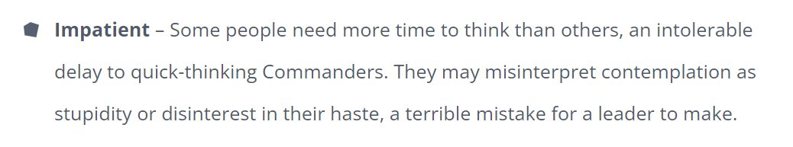.

Indeed, I'm impatient, and the way to solve this problem is to gradually learn how to control myself, respect other members and allow them to tell their opinion then discuss about it.

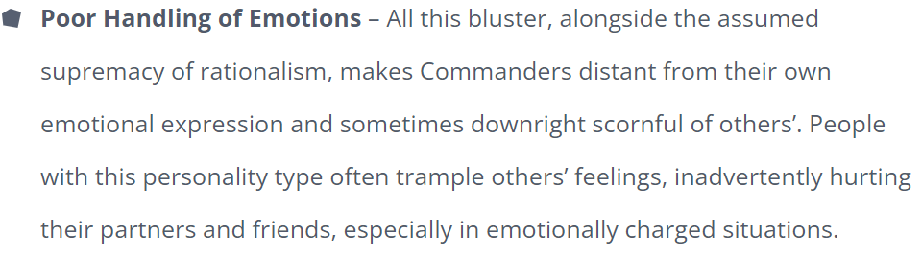

As the test tell me, I actually got stuck with handling my emotions, however, I think I can control my temper now because when working in a team, we have to accept and respect each other, therefore the productivity of the team may increase and it is much easier to achieve the team’s goals.

**How should you take this into account when forming a team?**

When forming a team, I will create the environment that all members must take their own responsibility, and everyone will be equal that they must contribute to the success of a team. When working with others, the way I communicate with one another may affect the productivity of the team. Because these are individuals with their own stories, they may have gone through a lot of hardship that we may not know, therefore a endure team is where individuals are respected and appreciated for their unmatched characteristics and their ability. Moreover, communicating is a huge problem with all members when they first take part in the team, as a leader I would connect the others by planning some event for the team such as: some project, charity work, bonding, and the like. As a result, the relationship between all members will be strengthened and therefore, increasing the productivity of the whole team.

**5. Project Idea:**

The project I always passionately wish to is a creating a game that easily can be played on both smartphones and computers simultaneously. The game will be a role-playing game that every client will have an in-game identity and they will be able to communicate with one another by the voice chat. Moreover, they will be able to play game-in-game with their friends or even watch movies together in the world that I will create. My project sounds like the Metaverse that Facebook are developing but it is much more basic than the Facebook's one.

Due to the Covid-19 pandemic, a lot of people must be locked down at their homes without any interactions to the real world and are not able to communicate with their friends. Moreover, staying at home too much may cause a lot of mental illness such as: depression, anxiety, trauma, and the like. In the future, who knows if there will be any natural devastations or infectious diseases. Therefore, I would create this game with the purpose of people keeping contact with one another as well as treating mental disease occurring often now. One of the significant reasons why I choose to create the game that people can easily get access to by whatever devices they use due to a lot of people just have either of devices mentioned above. Furthermore, it is portable for individuals to access to the game by their smartphone, however, having a better visual quality by using computer.

When first getting access to the game, players must fill in the confirmation forms including real name, date of birth, and some personal information. After that, player must accept the rules and the policies of the game which are very necessary. After logging in to game, people are able to customized their in-game identity which might be great if it sticks to their real identity. Moreover, characters can be customized further in-game by changing their clothes, tattoo, but it may take a bit of money to change the character’s appearance. However, after changing their appearance it may take a month for the next customization. Furthermore, people can choose a wide variety of actions like: smile, jumping, yelling face, and more to diversify their emotion when interacting with others. Besides, the specialty of this game is when individual speaks to the microphone, the character’s mouth will move. The game’s worlds would be created as cities in Vietnam. For example, Hanoi, the capital of Vietnam, the in-game city would be mimic the real-world city which has a lot of historical sites such as: Ho Chi Minh mausoleum, Temple of Literature, Old Quarter where inexperienced players can discover and do some quests to earn money and items.

As a role-playing game, there are diversity of jobs as much as the current real-world job that enable players to select. However, the players need to acquire some skills needed for their jobs. For instance, if the player wants to be a police man, they must spend their time to learn the rules and the policies of the city and practice many specialist skills like: shooting, how to deal with robbers, thieves, and so on. Besides, the most appealing factor of this game is player can find and trade items which can be exchanged to the real-world currency. Individuals can buy most of the items in the game such as: apartments, cars, clothes, planes and so on. Besides, there are many ways for the users to earn money: Completing quests, selling items, especially player can act as a terrorist to rob banks or hijack an airplane. After accumulating sufficient amount of money, clients will be able to buy apartments or a villa to park their personal vehicles.

As the duty of this game is to connect individual to others, playing as a crew is encouraged, people can make their own activities in this game like: racing, biking, or even playing board games. As a result, people receive more money in each of these activities depending on how many people take part in the game, and in some mission, it requires a team work to succeed. Furthermore, there are some secret mechanisms that players must discover, if they can find the secret places or items, they can trade it into real-world money by formatting it in NFT form. One more special mechanism in this game is when you cannot communicate directly with others, you can use the phone in-game for telecommunication. Therefore, it is easier for the team to keep in contact with one another when the mission requires team member to complete it at the same time in separate places.

To create this game, I tend to use CryEngine that provides me with the access to source codes and many studios that I need for my project. It has a wide range of functions that are needed to make an RPG (Role-playing game) such as: Building a near-real world with many innovative functions that create the realistic environment, and objects. Moreover, it also provides a function that fill the game’s world with the most realistic characters that may enhance the gaming experience. Besides the visual of this game, CryEngine also help game developers manipulate their knowledge of audio and bring it into the game. In terms of Hardwares, the computer that are able to create a game must have a good set of CPU, GPU (Graphics Processing Unit), RAM, and storage. Here are some latest technologies I know:

* CPU: Intel core I9-12900K (with Max Turbo Frequency up to 5.2 GHz)
* RAM: as much as possible
* GPU: RTX 3090 Ti (with Ray Tracing technology) or Quadro GV100 (designed for professional graphics design)
* Storage: SSD (as much as possible)

There are many skills which are needed for my project. First, gathering people and working as a team, it is crucial to make a team of game developers because a game requires a wide range of factors involving many different fields. Secondly, to bring the game to clients, the game must be in high visual quality along with suitable audio, therefore increasing the gamers’ experience. Last but not least, the spine of each game is its codes, as I would be a programmer, I will write a comprehensive code that enable the game to run smoothly. Now, it is extremely easy to search for game making engine and many Hardwares that need for game development on google and many search engines.

If the project is successful, indeed, I can earn a lot of money and fame from this. Besides, people can take advantage of it to make digital property and exchange it to real-world fortune. Moreover, people are able to keep in touch with their friends and others by interacting in the game. As a result, the number of people suffering from mental disease may decrease. The only thing that I worry about is that when people overuse the game and get addicted to it, they will have a tendency to get away with the real world and may cause some physical disease such as: myopia, obesity, and more.